Appunti Optimization Alghorithms

Lezione 4 30/09
→ SubTourElimination
→ CutSet
Vogliamo dimostrare che è stronger di
This is eventually possible proving that Pis contained in.
- Se è dentro allora prendendo una qualsiasi soluzione di questa risulta soluzione di .
- Inoltre l'inclusione deve essere stretta:

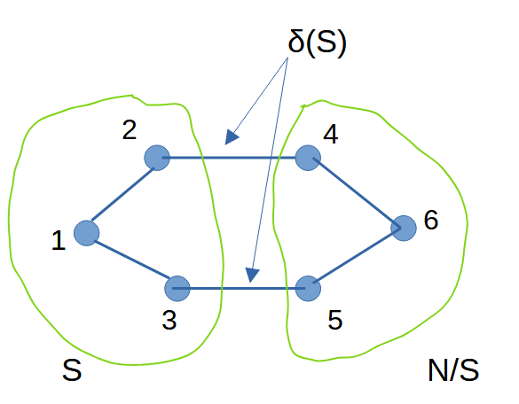

Given that:

We now want to prove that solutions that satisfy problems with Sub-Tour-Elimination constraints satisfy by consequence also problems with CutSet constraints. That means that solutions of the problem with STE constrains are also solutions of the CutSet formulated problem.

The spannig tree constraints assure us that:

Starting from the following true equation:

Sub-Tour constraints

So the equation above can be looked:

So:
that means tha CutSet constraints are satisfied by consequence of satisfaction of SBT constraints.

►Let's now consider the opposite situation:
so:

ho quindi informazioni sulla somma ma non posso affermare nulla sui singoli sottoinsiemi.

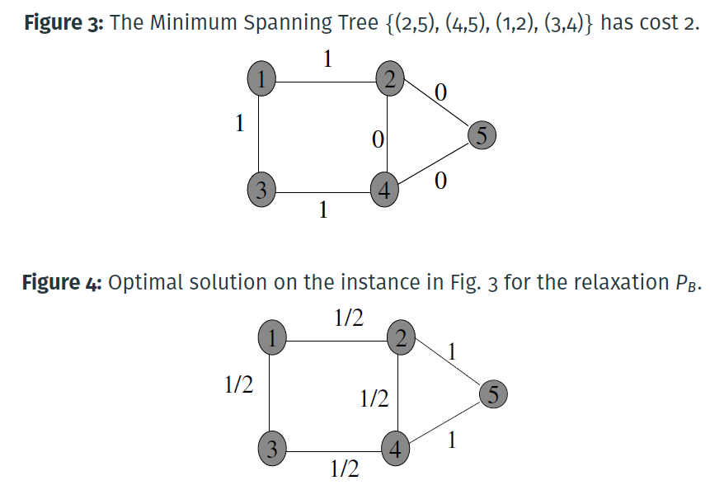
ESEMPIO:

Nella figura 3 sono rappresentati i costi.
Nella figura 4 sono invece rappresentati i valori assunti dalle variabili. Istanza di una soluzione.

La soluzione assume valore nel rilassato pari a
We wonder if this is a feasible solution for the CutSet formulated problem; that answer is a trivial yes, checked visually.
Now lets check if that solution is feasible for the SubTourElimination problem;
the answer is No. Consider infact the nodes 2,4,5:
the sum:

The solution in figure 3 is then feasible for but not for .
Remark that PLa formulation corrisponds to the Convex Hull.

Perfect Matching
This problem consists in finding the correct association between an even number of elements (that could be people).
Each connection between elements of the set has a cost associated.
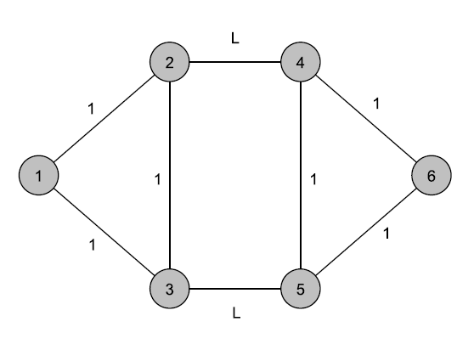
The problem is then set as an undirected graph

Formulation A (L>1)
Weak
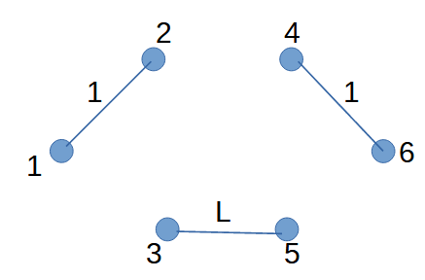

Looking at the optimal solution of the LP relaxation: it matches odd number of people.

Formulation B (L>1)
E' il Convex Hull.

Given a problem, if we don't have the exact algorithm we can then use a Heuristic algorithm.
Heristic algorithms: are able to find a good feasible solution in polynomial time.
The solution is not garanted to be Global, but is Local.
Efficiency: bounded to the computing time of an algorithm. It is efficient if the solving time is polynomial.
Efficacy: bounded to the quality of the solution.

A method can be valued looking at:
_the Average: which is the performance on a large set of problems
_Worst case performance: that consist in finding the worst possible scenario of a problem instance (which is not easy to find) and then look at the result found.

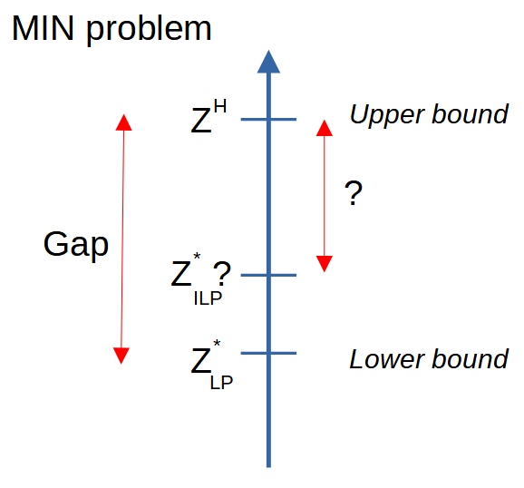
The lower Bound is easy to find.
We can therefore know how much is the gap and so we can have an OverExtimation of the error.

A Strong formulation provides a smalle gap.

Lezione 6 07/10
An heurstic therefore determines an Upper Bound on the optimal value.
Considering a minimization problem.

The Gap is the distance between and , which is found by the heuristic.
A big gap could be caused by a bad LP relaxation formulation or by a bad heuristic.
An herustic first: using a constructive method, ireratively, determines new elements to add until a complete solution has been reached.
Then using a local search algorithm tries to improve the solution, creating a trajectory (that is a sequence of feasible solutions) that iteratively improve the value of the object function, until there is no more a better solution.
Examples of constructive methods are the algorithms seen in the case of knapsack problem.

A Rule/Criterion is needed to step from

The Neighborhood of is a set of solutions close to .
What is close to is any feasible solution that is reachable starting from making a move, which is an operation to create a near solution (?).

Once i have a neighborhood we have to explore it, looking for a better solution.

Example: TSP
let's start by building an initial feasible solution.

Starting from a self-loop.
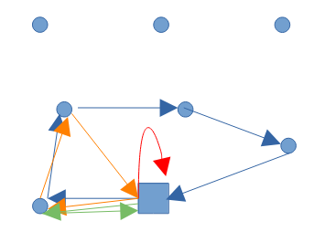
Next we have to (1) select the element to be added, using a Rule/ Metrics.
Then we have to determine where to (2) insert the element.

A way to insert could be using the cheapest insertion:

Remark that subsists the triangular inequality so

Criteron to select the next vertex:
►Nearest neighbor: select the external node closer to the cycle. This require to compute, for each node, all possible distances and then determine which distance is the lowest.

►Farthest insertion: selecte the vertex with the maximum distance from S. This works pretty well beacause it take care of worst cases first so that other will fit by consequence.
►Arbitrary insertion: take complete randomly the next node.
►Cheapest insertion: take the one that minimize the cost of insertion

The insertion works following the cheapest insertion criterium.

Analysis
How to evaluate the quality of an algorithm?
1) Experimental:
-using a total random generated insances (usually this problems result easy to solve)
-using correlated instances is usually a better decision
-using benchmark instances

2) Worst Case:
gives in return a goodness certificate.

Greedy Algorithm for the TSP:
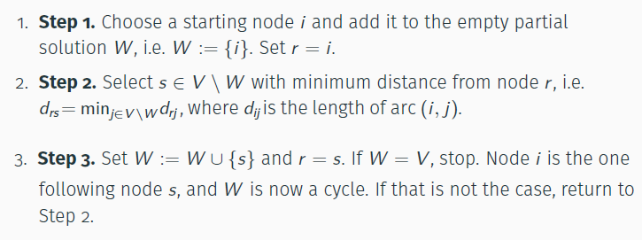

TSP worst case example:
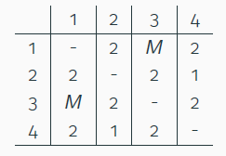
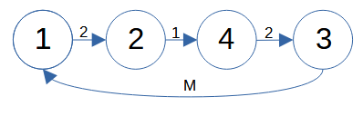

With a cost:

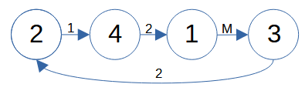

With a cost:

The question is: can we have a cycle without M?
Yes:
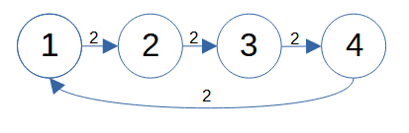

With a cost: 8

So if the heuristic find the optimum.
If the heuristic solutions and the other one are the same.
If the heuristic solution is not the optimum.

Neighborhood Function:
Given an optimization problem
S is the set of all feasible solutions for P;
f is the objective function.

The Neighborhood is a subset of solutions
In other terms is an element of the power set:

given a solution a find another solution.

Explore the neighborhood:
First improvement:
stop once found a better solution.

